CLI (Command Line Interface)
For the CLI, you can provide a Python script that renames a file via command-line arguments. Here's how you could implement it:
Python Code
import os
import sys

def rename_file(old_name, new_name):
try:
os.rename(old_name, new_name)
print(f"File renamed from {old_name} to {new_name}")
except FileNotFoundError:
print(f"Error: {old_name} not found.")
except Exception as e:
print(f"An error occurred: {e}")

if __name__ == "__main__":
if len(sys.argv) != 3:
print("Usage: python rename_file_cli.py <old_filename> <new_filename>")
else:
rename_file(sys.argv[1], sys.argv[2])

How it works:
The script accepts command-line arguments for the old and new filenames and renames the file.

How It Works:
- Imports:
  - os for interacting with the file system.
  - sys for accessing command-line arguments.
- Function rename_file:
  - Takes two arguments: old_name (current filename) and new_name (desired new filename).
  - Tries to rename the file using os.rename().
  - Handles FileNotFoundError if the original file doesn't exist.
  - Catches any other unexpected exceptions.
To use it:
python rename_file_cli.py oldfilename.txt newfilename.txt

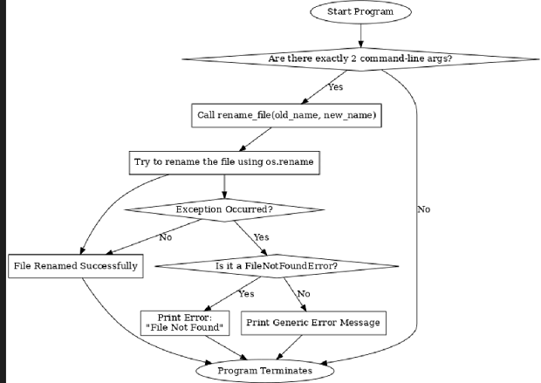

GUI (Graphical User Interface)
In the GUI, we will use Tkinter to create a simple interface where the user can type the old and new filenames.
import tkinter as tk
from tkinter import messagebox
import os

def rename_file():
old_name = old_filename_entry.get()
new_name = new_filename_entry.get()

try:
os.rename(old_name, new_name)
messagebox.showinfo("Success", f"File renamed from {old_name} to {new_name}")
except FileNotFoundError:
messagebox.showerror("Error", f"File {old_name} not found.")
except Exception as e:
messagebox.showerror("Error", f"An error occurred: {e}")

# Set up the main window
root = tk.Tk()
root.title("File Renamer")

# Create and place labels, entries, and buttons
tk.Label(root, text="Old Filename:").grid(row=0, column=0)
tk.Label(root, text="New Filename:").grid(row=1, column=0)

old_filename_entry = tk.Entry(root)
old_filename_entry.grid(row=0, column=1)

new_filename_entry = tk.Entry(root)
new_filename_entry.grid(row=1, column=1)

rename_button = tk.Button(root, text="Rename File", command=rename_file)
rename_button.grid(row=2, columnspan=2)

# Start the Tkinter event loop
root.mainloop()

How it works:
The GUI allows the user to input the old and new filenames, then click a "Rename File" button. Upon clicking the button, it attempts to rename the file and provides feedback via a message box.

Visual Layout:
- Window Title: File Renamer
- Size: 400x150 pixels (fixed, not resizable)

🗂️ Old Filename:
(Entry field aligned to the right with enough space to type file names)

📝 New Filename:
(Another entry field right below the first one)

✅ Rename File Button:
- Color: Green background with white text
- Text: "Rename File"
- Centered below the input fields

When you click the Rename File button:
- A pop-up will appear:
  - Success Message: Green tick icon with a confirmation.
  - Error Message: Red cross icon if there's an issue.
  - Warning: Yellow triangle if inputs are empty or overwriting a file.

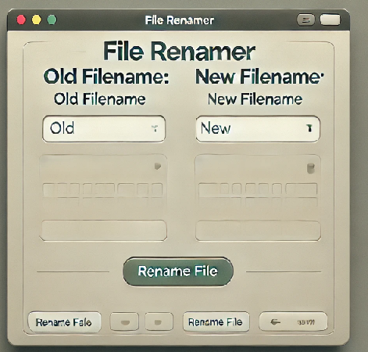

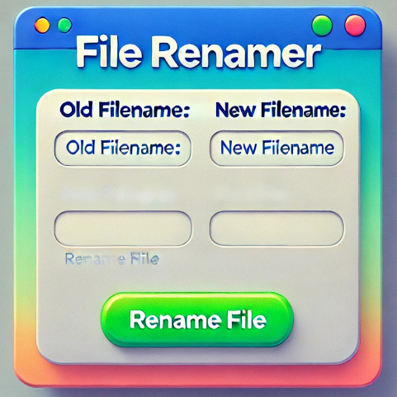

VUI (Voice User Interface)
For the VUI, we can use the SpeechRecognition library to listen for voice commands. The user will say something like, "Rename oldfilename.txt to newfilename.txt."
import speech_recognition as sr
import os

def rename_file_from_voice_command(command):
# Extracting old and new filename from the command
try:
words = command.split(" ")
old_name = words[1]
new_name = words[3]

os.rename(old_name, new_name)
print(f"File renamed from {old_name} to {new_name}")
except Exception as e:
print(f"Error: {e}")

def listen_for_command():
recognizer = sr.Recognizer()
mic = sr.Microphone()

print("Listening for command to rename a file...")
with mic as source:
recognizer.adjust_for_ambient_noise(source)
audio = recognizer.listen(source)

try:
command = recognizer.recognize_google(audio)
print(f"Command received: {command}")
rename_file_from_voice_command(command)
except sr.UnknownValueError:
print("Sorry, I couldn't understand the command.")
except sr.RequestError as e:
print(f"Could not request results from Google Speech Recognition service; {e}")

if __name__ == "__main__":
listen_for_command()

How it works:
- The script listens for voice input using the microphone and recognizes the command using Google’s speech recognition engine.
- The user can say something like: "Rename oldfilename.txt to newfilename.txt."
- The script extracts the filenames and attempts to rename the file.

Installation:
Ensure you have the necessary libraries installed:
pip install SpeechRecognition
pip install PyAudio # For microphone input



User Satisfaction Comparison
To assess user satisfaction, you can compare the interfaces on the following aspects:
- Efficiency (Time to complete task):
  - CLI: Most efficient for advanced users.
  - GUI: Moderate efficiency, dependent on visual navigation.
  - VUI: Dependent on speech recognition accuracy and environmental conditions.
- Learning Curve:
  - CLI: Steep for non-technical users.
  - GUI: Easy to learn for most users.
  - VUI: Very shallow, as it mimics natural language commands, but voice accuracy issues might hinder this.
- Error Handling:
  - CLI: Minimal feedback, error prone for typos.
  - GUI: Provides visual feedback with error messages.
  - VUI: Dependent on recognition; can misunderstand commands if not clear.

- User Satisfaction:
  - CLI: Likely to be rated low by non-technical users, but advanced users will be very satisfied.
  - GUI: Likely to be rated highly by most users due to ease of use.
  - VUI: Satisfaction depends on voice recognition accuracy; users may find it convenient for hands-free tasks, but errors can cause frustration.

How to Measure User Satisfaction
You can implement a simple survey to measure user satisfaction after each task completion. For example:
def survey():
print("Rate your satisfaction with the following interfaces (1-5):")
cli_satisfaction = int(input("CLI (1-5): "))
gui_satisfaction = int(input("GUI (1-5): "))
vui_satisfaction = int(input("VUI (1-5): "))

print(f"\nYour satisfaction ratings:")
print(f"CLI: {cli_satisfaction}")
print(f"GUI: {gui_satisfaction}")
print(f"VUI: {vui_satisfaction}")

Final Thoughts
- CLI is best for power users who need speed and control.
- GUI is ideal for most users due to its intuitive nature and ease of use.
- VUI provides a hands-free experience, though it may be prone to inaccuracies

